**Practical – 2**

**Aim: -** Create Web forms and pages that properly use HTTP GET and POST protocol as appropriate.

**Code: -**

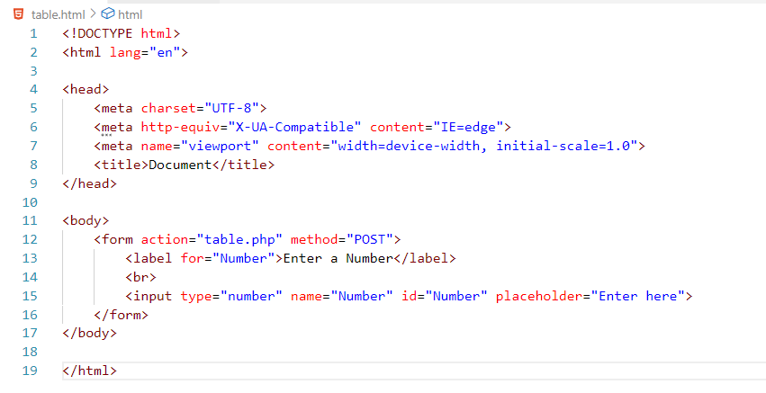

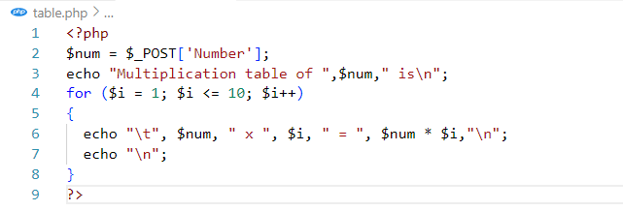

**Result: -**

